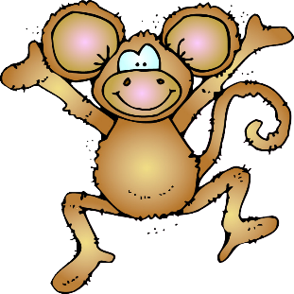
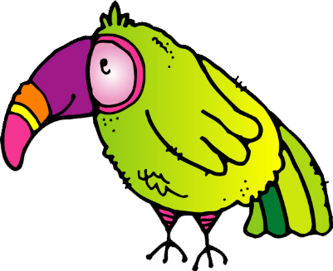
Tropical Animals Font Practice

Sarah the Fancy Sloth | Pete the Loud Parrot | Sam the Smooth Snake | Minnie the Crazy Monkey | Leo the Large Leopard | Lizzy the Little Lizard | Tim the Talkative Toucan

