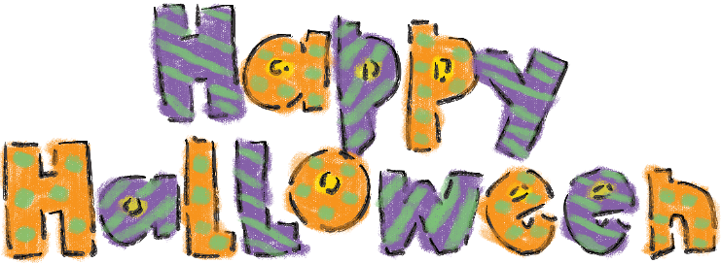

|  |  |  |
| --- | --- | --- |
|  | **bat** |  |
|  | **black cat** |  |
|  | **pumpkin** |  |
|  | **monster** |  |
|  | **web** |  |
|  | **witch** |  |
|  | **ghost** |  |