Practice with Word

Change this line to your favorite color.

Center this line.

Italicize this line.

Change this line to size 24.

Highlight this line yellow.

Make this line bold.

Change this line to all capital letters.

Underline this line.

In the table below, cut and paste the pictures from the bottom row, to the middle row, so that the picture on the middle row belongs with the correct picture on the top. The pictures should match by holiday!

Outline the text in this line in red. The outline should be ½ point thin.

Change this line to Courier New font, size 18.

Make a copy of this line and paste it right below this line.

Make a bulleted list of 3 things you can do outside in the winter. Use any kind of bullet you wish. Make your list below this line.

Below this line, add a shape of your choice. Make the shape green on the inside, outlined in hot pink, with a 3pt wide border.

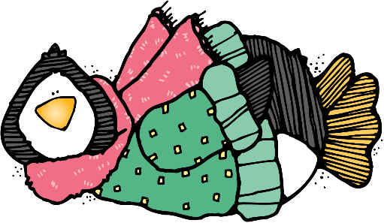

Add a shadow to the picture on the right.

Look in the Pictures Folder in Dropbox, K5 Computer Lab,

and insert a piece of clipart in the space below. Resize it to fit the space.

Below this line, add your name using Word Art. Center it in the space. Experiment with different designs, colors, etc.

