At the Beach

Author Mrs. DeLeon

Illustrator Name

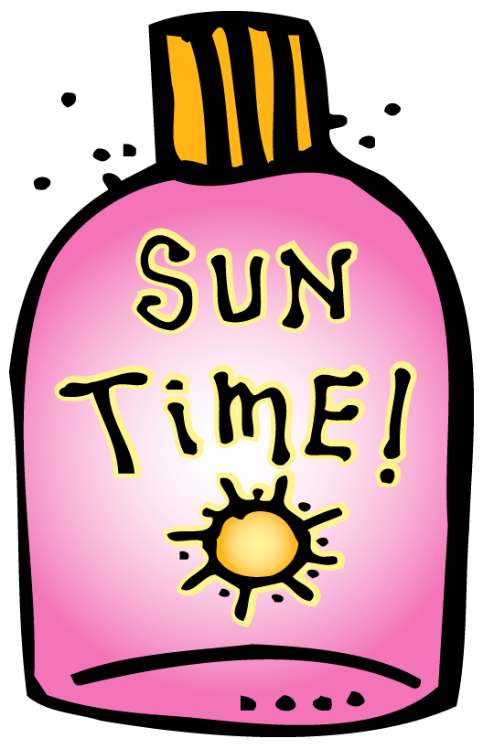
May 18, 2016

I go to the beach.

I see a fish.

I see a shell.

I see an umbrella.

