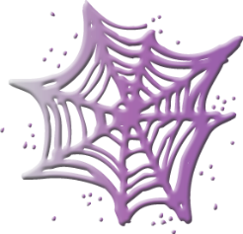

Halloween copy and paste

|  |  |  |  |
| --- | --- | --- | --- |
|  |  |  |  |
|  |  |  |  |

|  |  |  |  |
| --- | --- | --- | --- |
|  |  |  |  |
|  |  |  |  |

|  |  |  |  |
| --- | --- | --- | --- |
| orange spider | bat | haunted house | green monster |
| scary ghost | mummy | happy witch | cat in witch’s hat |

