|  |
| --- |
| A Mess |

|  |
| --- |
| **Name** Name |

|  |
| --- |
| May 3, 2013 |

Put the pictures in order.

|  |
| --- |
|  |

|  |  |  |
| --- | --- | --- |
| 1. | 2. | 3. |

Put the pictures in order.

|  |
| --- |
|  |

|  |  |  |
| --- | --- | --- |
| 1. | 2. | 3. |

Change the size of the pictures to make one **big**, one **bigger**, and one the **biggest**.



Change the size of the pictures to make the *child* **bigger** than the *baby*.

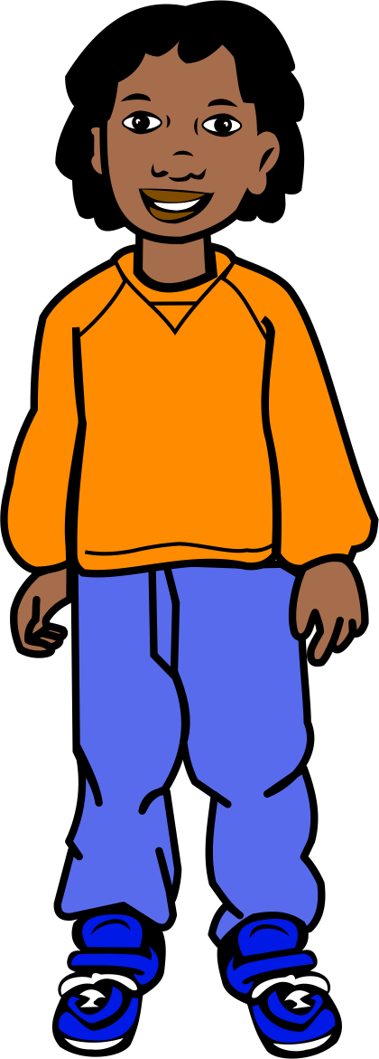BD09493_

AN02388_AN00988_BD08105_j0121575Make a picture.



